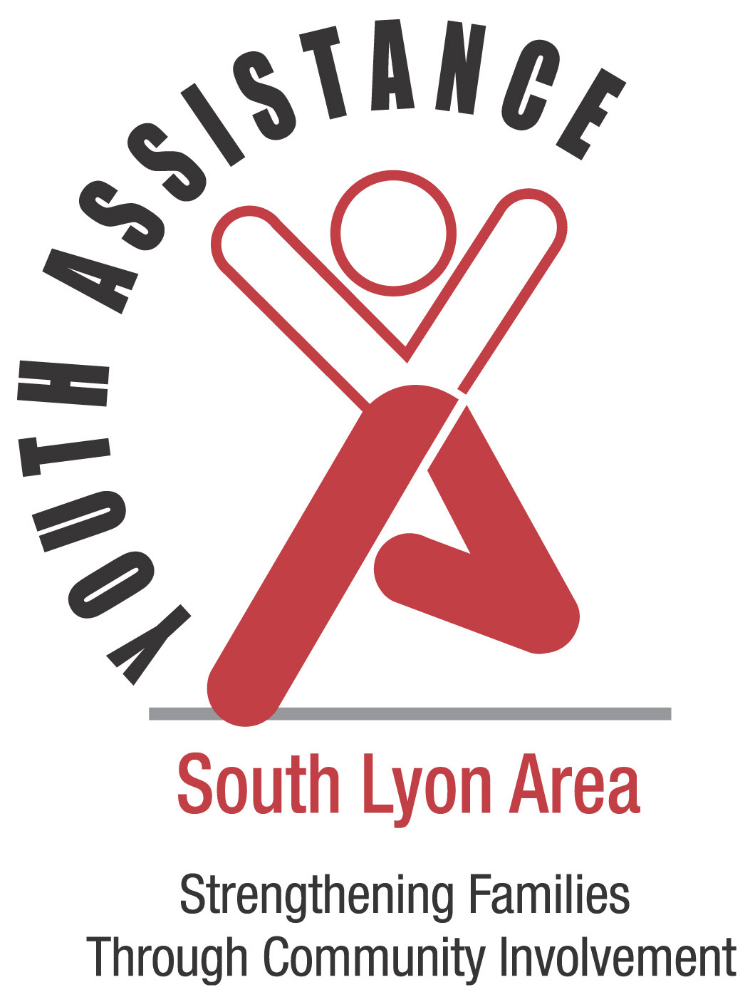SOUTH LYON AREA YOUTH ASSISTANCE

SUMMER ENRICHMENT REGISTRATION FORM
Please return this form to the SLAYA office via USPS or call (248) 573-8189 for drop off information.

Participant’s Name:
Birth date: |  |  |  |  |  |  |  |  |  | Age:
Grade in Fall 2020 |  |  |  |  |  |  |  |  | Sex: |  |  | Male Female
T-Shirt Size (YOUTH) |  |  |  |  | YS YM YL |  |  |  | Race: |  |  | White African-American
T-Shirt Size (ADULT) |  |  |  |  | S M L |  |  |  |  |  |  | Hispanic Asian  Native American Bi-Racial
Parent/Guardian’s Name:
Home Address: |  |  |  |  |  |  |  |  |  | City/Zip:
Home Phone: |  |  |  |  |  |  |  | Work Phone:
Session: | Elementary - $120 Middle School - $135 |  |  |  |  |  |  |  |  |  | Attending final performance: Yes No
 |  |  |  |  |  |  |  |  |  |  | Elementary 7/30, Mid-High 7/31
Additional information for directors of participants (allergies, behaviors, learning needs, etc.)
___________________________________________________________________________________________________

Email Address where we can send program information___________________________________________________

IN CASE OF EMERGENCY, THE FOLLOWING PERSON(S) MAY BE CONTACTED IF PARENT OR GUARDIAN ARE NOT AVAILABLE:
Name: |  | Phone:
Name: |  | Phone:

NAME OF PERSON OTHER THAN PARENTS TO WHOM CHILD MAY BE RELEASED:
Name: _____________________________________________________________ Phone:__________________

Consent and Release – Read before signing
I grant permission for my child to participate in the South Lyon Area Youth Assistance (SLAYA) Summer Enrichment program including all on-site and field trip activities. SLAYA is authorized to consent to emergency medical treatment if the need arises while the child is in the program. I agree to pay all costs incurred to provide medical care. I understand that SLAYA, its officers, directors, agents, and representatives, and employees, whether voluntary or employed, assume no responsibility for any injury suffered by or medical emergency occurring to this child in the course of the program. On behalf of myself and this child and to the full extent permitted by law, I hereby release exonerate, and discharge SLAYA and its officers, directors, agents, representatives, and employees, whether voluntary or employed, for any and all liability, damages, actions, or causes of action for any injuries suffered by or medical emergency occurring to this child while enrolled in the program.
In addition, I understand and agree that SLAYA and/or its officers, directors, contractors, agents, and representatives will and are hereby authorized to make audio and or video tapings of the Summer program activities, photographs and edit these at its discretion. On behalf of myself and this child, I hereby authorize SLAYA without payment to myself or on behalf of this child, to record this child’s picture and voice on photographs, films, and tapes, to edit these recordings at its discretion, and to incorporate these recordings into movie and sound films, broadcasts programs, public relations and advertising materials, Facebook, and Instagram.

X PARENT/GUARDIAN SIGNATURE:___________________________________________ DATE:________________
In which municipality are your property taxes paid? (please check one):

Commerce Township Green Oak Township Lyon Township Milford Novi

Northfield Township Salem Township South Lyon Wixom

New funding regulations from Lyon Township require us to track the number of low-income families that South Lyon Area Youth Assistance serves. This information is only reported as a number; no names are reported.
If you live in Lyon Township, the following question MUST be answered.

Step 1: Please CIRCLE the total number of people who live full time in your household.
Step 2: Please CIRCLE the amount on the same line that describes your total household income from all
sources.
Persons in Household | Extremely Low Income | Very Low Income | Low Income
1 | Less than $14,900 | Less than $24,850 | Less than $39,700 | Greater than $39,700
2 | Less than $17,000 | Less than $28,400 | Less than $45,400 | Greater than $45,400
3 | Less than $20,780 | Less than $31,950 | Less than $51,050 | Greater than $51,050
4 | Less than $25,100 | Less than $35,450 | Less than $56,700 | Greater than $56,700
5 | Less than $29,240 | Less than $38,300 | Less than $61,250 | Greater than $61,250
6 | Less than $33,740 | Less than $41,150 | Less than $65,000 | Greater than $65,000
7 | Less than $38,060 | Less than $44,000 | Less than $70,650 | Greater than $70,650
8 | Less than $42,380 | Less than $46,800 | Less than $74,850 | Greater than $74,850

Affidavit
APPLICANTS CERTIFICATION: The applicant certifies that all information in this application and all information furnished in support of this application is for the purpose of obtaining funds for the improvement of the above mentioned property, and that these statements are true to the best of the applicant’s knowledge and belief.
PENALTY FOR FALSE OR FRAUDULENT STATEMENT: U.S.C. title 18, Sec. 1001, provides: "Whoever, in any matter within the jurisdiction of any department or agency of the United States knowingly and willfully falsifies…or makes any false, fictitious or fraudulent statements or representations, or makes or uses any false writing, or document knowing the same to contain any false, fictitious or fraudulent statement or entry, shall be fined not more than $10,000 or imprisoned not more than five (5) years, or both."

SIGNATURE_______________________________ DATE:____________
-------------------------------------------------------------------------------------------------------------------------------------------------------------------------------------------------------------
OFFICE USE ONLY:
PAID Check #: __________ ____Cash ____Credit Card Amount Collected: $_____________
MAP CHECK GRID: ___________ LT? 0 YES 0 NO

